|  |  |  |  |
| --- | --- | --- | --- |
| Activate function  results | Relu | sigmoid | Square |
| Test Accuracy | 0.989 | 0.9652 | 0.098 |
| Runing time /second  (Training and Testing) | 1124 | 1142 | 1168 |

**MNIST**:

Training data:

10000*batch(50)=50000 records

Testing data:

20000 records

Platform:

CPU:intel core i5 1.6GHz

OS: MacOS 10.12

**NN structure:**

1. convolution layer

strides: [1,2,2,1]

kernel size: 5*5

feature map: 5*14*14(padding=’SAME’)

1. square activation layer

square the value at each node

1. pool layer

strides: [1,1,1,1]

kernel size: 1*3*3

output: 5*14*14(padding=’SAME’)

1. convolution layer

strides: [1,2,2,1]

kernel size: 5*5

1. pool layer
2. fully connected layer
3. square activation layer
4. fully connected layer
5. softmax activation layer

**BreastCancer-Wisconsin(Diagnostic)**

**Dataset Desciption:**

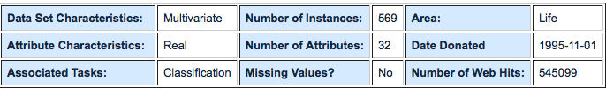

Attribute information

1) ID number

2) Diagnosis (M = malignant, B = benign)

3-32)

Ten real-valued features are computed for each cell nucleus:

a) radius (mean of distances from center to points on the perimeter)

b) texture (standard deviation of gray-scale values)

c) perimeter

d) area

e) smoothness (local variation in radius lengths)

f) compactness (perimeter^2 / area - 1.0)

g) concavity (severity of concave portions of the contour)

h) concave points (number of concave portions of the contour)

i) symmetry

j) fractal dimension ("coastline approximation" - 1)

**NN Structures and Training results**

3 hidden layer deep neural networks,with hidden units of [10,20,10]

Training steps: 20000

Training data: 458 records Testing data: 111 records

Training time: 36 seconds Testing time: 0 second

Test Accuracy:0.924

**Note:**

Some warnings appears due to the Estimator is decoupled from Scikit Learn interface by moving into separate class SKCompat and tensorflow's V1 checkpoint format has been deprecated.

**BreastCancer-Wisconsin(Origianl)**

**Dataset Desciption:**

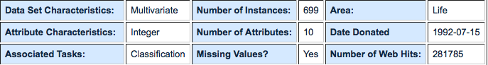

Attribute information

1) ID number

2) Diagnosis (M = malignant, B = benign)

3-32)

Ten real-valued features are computed for each cell nucleus:

a) radius (mean of distances from center to points on the perimeter)

b) texture (standard deviation of gray-scale values)

c) perimeter

d) area

e) smoothness (local variation in radius lengths)

f) compactness (perimeter^2 / area - 1.0)

g) concavity (severity of concave portions of the contour)

h) concave points (number of concave portions of the contour)

i) symmetry

j) fractal dimension ("coastline approximation" - 1)

**NN Structures and Training results**

3 hidden layer deep neural networks,with hidden units of [10,20,10]

Training steps: 20000

Training data: 677 records Testing data: 6 records

Training time: 41 seconds Testing time: 1 second

Test Accuracy: 1.0000

**Note:**

Some warnings appears due to the Estimator is decoupled from Scikit Learn interface by moving into separate class SKCompat and tensorflow's V1 checkpoint format has been deprecated.

**Arcene Dataset**

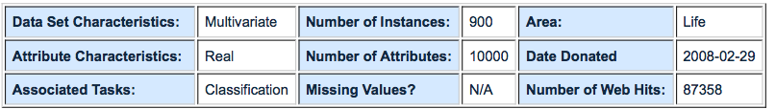

training data: 705 steps

loss : [12.035118]

runing time: 45.3 seconds

predictions and weights matrix:

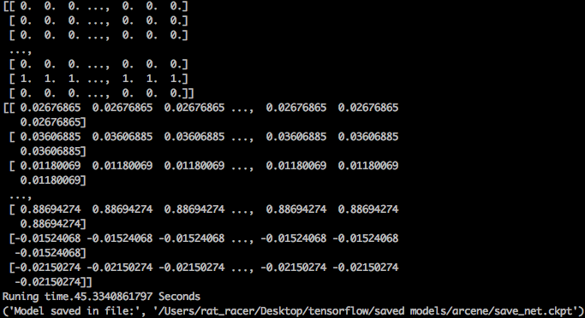

**Nursery Dataset**

To be continued